# Representation of STEP AP210 package models to support thermal analysis

#### James Stori and Spencer Burton SFM Technology, Inc., October 31, 2011

STEP AP210 (ISO 10303-210) enables a unified representation of electronic component models capable of supporting a variety of engineering design and analysis disciplines. AP210 package models may contain detailed three-dimensional geometric representations to support mechanical design applications, two-dimensional layered representations (including footprints and padstacks) to support PCB layout requirements, and functional network representations to support electronics design and simulation applications.

Thermal analysis is one of the most common mechanical analyses carried out in the design of electronic systems. Approximate thermal analysis can be conducted based on simplified thermal-network representations of electronic components and systems. High-fidelity thermal analysis is typically carried out using a computational fluid dynamics (CFD) approach. CFD analysis requires three-dimensional geometric representations of the various elements of the system, coupled with applicable material properties such as the thermal conductivity and surface emissivity. Modern CFD packages targeted at electronics applications often support hybrid analysis combining CFD simulation with simplified network-based representations. Individual electronic components may be represented with either detailed models of the IC package, where the internal structure is explicitly modeled, or so-called compact thermal models based on a network representation.

This document provides a recommended practice for the representation of both detailed and compact thermal models of electronic packages to support both network-based and CFD analysis applications. To demonstrate the approach, a case study has been carried out on a representative PCA within an enclosure. A series of AP210 package models have been constructed spanning detailed and compact thermal model representations. Geometric data, material properties, and thermal resistance values from these AP210 package models has been extracted and used to create library components within a leading commercial CFD application through conversion to a proprietary XML input format. The case study demonstrates that the proposed AP210 package representation structure can successfully support the data requirements of thermal analysis.

### Notation

In the discussion that follows, ARM application objects will be written with the leading character capitalized (i.e. Shape_element), while MIM entities will be written in all lower case (shape_aspect).

## Overview of AP210 Package Model Representation

Figure 1 outlines the top-level MIM entities in the AP210 package model. A package typically contains a package_body, multiple package_terminals, and a seating_plane. These shape_aspects describe the functional elements of the package relevant for design. A package can have one or more footprint_definitions associated with it. The footprint contains the specification of padstacks and other layered design elements (copper, soldermask, silkscreen, etc) to be included in the PCB to support assembly and mounting requirements of an instance of the package in a design. Padstacks within a footprint may be explicitly related to terminals in the package. The package can also have multiple shape_representation associated with it. Each is either a two-dimensional or three-dimensional geometric model for a particular purpose. For example, a shape_representation could be a two-dimensional keepout representing the extent of the package in a pcb design. In a model intended to support mechanical design requirements, the package will typically have a detailed three-dimensional representation with an explicit mapping to the various physical package features (body, terminals, etc.).

The ARM Shape_element application object (shape_aspect) is used to identify features or elements of a physical representation that are relevant for a particular purpose within an application context. The functional package elements such as the body, terminals, and mounting features are subtypes of shape_aspect. GD&T annotations are also represented as shape aspects in STEP. A shape_aspect may be explicitly associated with elements of a geometric model through an item_identified_representation_usage. Common subtypes of item_identified_representation usage include draughting_model_item_association, geometric_item_specific_usage, and usage_concept_usage_relationship. Each item_identified_representation_usage associates a representation_item within a specified representation with the shape_aspect. These representation_items are most typically a face or solid within a geometric model. In the context of an AP210 package model, there are two common representations of the geometric structure. In an assembly-style package representation, the geometric models of the package_body and package_terminals are typically represented as an advanced_brep_shape_model placed into the shape_representation of the package with a usage_concept_usage_relationship, which is a subtype of both mapped_item and item_identified_representation_usage. In the case of the single-solid package representation, the geometric representation of a package feature such as a terminal or body is a collection of faces. In this case, each face would be related to the shape_aspect through an individual item_identified_representation_usage.

## Detailed Package Model Representation for Thermal Analysis

CFD simulation is highly computationally demanding. For this reason, it is important that an appropriate level of detail be employed for the each element or subsystem to be analyzed. The requirements of a geometric model to be used in thermal analysis may be significantly different than the requirements of alternate design and analysis use cases requiring either greater or lesser degree of detail. If the thermal model is developed by a component vendor for the purpose of distribution to end users, geometric detail may be reduced in order to protect proprietary aspects of the package construction.

Nevertheless, the level of detail must be adequate to faithfully reflect the thermal behavior of the package, and support accurate prediction of die and case temperatures. Some of the important issues regarding the construction of package models for thermal analysis are addressed in a series of application notes developed by Sarang Shidore, previously of Flomerics, Inc.[1][2][3][4][5] Figure 2 illustrates the level of detail that might be employed in a detailed thermal model of an SOIC package, along with some of the key features in a typical thermal model representation (elements of the leadframe are not displayed for clarity). While the precise mechanical contact between a physical package terminal and a corresponding pad on a PCB may be important for predicting solder-joint reliability, this level of physical detail is unnecessary and likely detrimental to the thermal analysis. Conversely, the size, location, and position of the die within the package will be critical to the thermal behavior of the package within an assembly. It is also common practice in a thermal analysis model to simplify the geometric representation by lumping together groups of neighboring terminals or similar features such as bond wires into a single simplified shape with effective material properties. When doing so, an equivalent series resistance is calculated for heat flow across the individual elements, and the thermal conductivity in the direction transverse to the discrete elements is replaced by an effective thermal conductivity based on the equivalent series resistance.

In order to support an explicit association of material properties with geometric features of the thermal analysis representation, the recommended practice is to populate each as a shape_aspect of the package. The representation of material properties and their association with these shape_aspects is discussed below. Figure 3 illustrates the population of dual geometric representations and corresponding features within a single package model. A package can support multiple three-dimensional geometric models (Physical_unit_3d_shape_models). The optional attribute predefined_3d_purpose enables identification of the application intent of the individual model through an enumeration. A shape purpose of ‘thermal_analysis_input’ identifies the shape representation to be used in thermal analysis, while the shape purpose of ‘design’ is used for the detailed physical package model. The entities and relationships used in the MIM mapping of the Physical_unit_3d_shape_models and predefined_3d_purpose are detailed in Figure 3.

As illustrated in Figure 3, a series of shape_aspects are associated with each of the two shape_representations (Physical_unit_3d_shape_model). There are multiple possible mechanisms for representing the geometric features in the thermal analysis model. Each of the geometric regions will typically be represented as a single geometric_representation_item with the shape_representation. Common possibilities include subtypes of solid_model such as a csg_solid or a manifold_solid_brep, or a simple geometric_representation_item with a parametrically specified three-dimensional shape such as a block or right_circular_cylinder. In the package models developed for the case study accompanying this recommended practice, each of the geometric features is represented as an independent shape_representation placed into the thermal analysis representation as a mapped_item. Figure 4 illustrates the use of the geometric_item_specific_usage subtype of item_identified_representation_usage to associate a three-dimensional shape with a shape_aspect in the thermal model representation.

#### Non-package thermal analysis representations

There are numerous components and/or subsystems in an electronics assembly that are not physical component packages. Examples include heat sinks, mounting brackets, and enclosures. For the purposes of thermal analysis, it is often desirable to provide an approximate thermal representation with associated material properties, and treat these as library components as well. Such components may be represented as a physical_unit (supertype of package), as illustrated in Figure 5. In this way, a typical mechanical component can be provided with an alternate shape_representation for the purposes of thermal analysis. In the case of an existing mechanical model, the physical_unit would replace the product_defintion and product_definition_shape that relates the shape_representation to the product_definition_formation in the AP203 representation. Multiple shape_representations may be associated with the physical_unit, and a ‘predefined shape purpose’ of ‘thermal_analysis_input’ can be used to identify the thermal analysis representation. There may or may not be any shape_aspect associated with the mechanical model. In the case of GD&T annotations, these would be associated with the ‘design’ representation of the physical_unit.

### Representation of Material Properties

To support thermal analysis, it is necessary to associate material and surface properties with the individual features (shape_aspect) in the thermal analysis representation. Thermal conductivity is the most important property needed for steady-state thermal analysis. In many electronic applications, such as the effective series-resistance approximation described previously, isotropic material properties are inadequate, and it is necessary to express conductivity values independently for the primary directions. For transient analysis, material density and specific heat are required. Finally, surface emissivity must be provided if radiant heat transfer is to be simulated.

As material properties used in thermal analysis are often approximate and/or effective properties, rather than properties of formally defined materials, it is recommended that the properties be expressed as a generic Assigned_shape_property rather than Material_property or General_material_property. Both Material_property and General_material_property require a known Data_environment be provided through the Material_property_value_representation. This is both inapplicable and cumbersome in the case of approximate or applied properties.

Figure 6 details the MIM mapping of an Assigned_shape_property and its corresponding Representation, as well as the association with one or more Shape_element (shape_aspect). Each individual property will be expressed as a property_definition associated with a representation that contains a single measure_representation_item with a measure_value and an associated unit. The name attribute of the property_definition will contain a label identifying the individual property.

A collection of material properties can be associated with an individual shape_aspect, or they may be associated with a group of shape_aspect through a composite_group_shape_aspect. The interpretation of the composite_group_shape_aspect is that a property associated with the composite_group_shape_aspect is effectively applied to each of the individual shape_aspect in the composite group.

Figure 7 provides a detailed example of the representation of a material property, and its association with either a shape_aspect or composite_group_shape_aspect. In this particular case, the property is a thermal conductivity, expressed as W/mK. The derived_unit has three derived_unit_element containing the exponents and base SI units composing the derived unit. The AP210 package models generated for the case study contain representations for all of the commonly required material and surface properties used in thermal analysis.

## Compact Thermal Model Representation

The preceding discussion has been focused on the representation of thermal models of packages based on their physical composition. Detailed thermal models provide the highest degree of fidelity, and most faithful representation of thermal behavior within the package. In many cases, however, a compact thermal model (CTM) based on a network representation is an effective and efficient approach to supporting thermal analysis of complex electronic systems. In a thermal network representation, a component is modeled through a limited number of isothermal ‘nodes’ interconnected with ‘thermal resistors’.

The JEDEC JC-15.1 Committee on Thermal Characterization Techniques for Electronic Packages and Interconnects has been actively involved in the development of standards for thermal modeling, with an emphasis on compact thermal models[6][7]. Figure 8 depicts the two most common network representations of an electronic component supported through the JEDEC standards. In the ‘two-resistor’ representation, there two thermal resistances approximate the resistance to heat transfer between the case, junction, and board nodes. Heat is generated at the junction, and the case and board nodes are treated as isothermal and serve as the interface with the external system to be analyzed. The two-resistor representation is generally regarded as the least complicated model that captures a reasonable description of thermal performance[8]. The ‘Delphi’ model supports a more complex network representation with additional nodes and interconnecting thermal resistors. A variety of network topologies are possible within the Delphi framework. For example, if significant asymmetry is anticipated, it may be necessary to add additional nodes to reflect differing temperatures on the individual sides of the component.

A previous recommended practice has addressed the representation of thermal resistor networks of packaged components in STEP AP210,[9] and should be referenced for a detailed explanation of the relevant concepts and representation details. Figures 9 and 10 highlight some of the key structural elements and concepts in the MIM representation of a thermal resistor network. The thermal_network is associated with the package through a product_definition_relationship with name ‘thermal model assignment.’ A thermal_network is composed of a series of nodes (thermal_network_node_definition) and interconnecting elements between these nodes consisting of thermal resistors. Both the thermal_network and a thermal_resistor are definitions of Functional_products. An instance of a thermal resistor is a component_functional_unit that references a functional_unit (the ‘usage_view’ of the product representing the thermal resistor). An instance of a thermal resistor has two terminals (component_functional_terminal) and these terminals are connected to the applicable nodes of the thermal network. The value of the thermal resistance is populated through a parameter_assignment related to the component_functional_unit, as detailed in Figure 10. The thermal resistance value is represented as a complex of thermal_resistance_measure_with_unit and measure_representation_item.

### Associating a network node with a location in a geometric model

When conducting a CFD analysis that incorporates thermal network models, it is necessary to provide a mapping between nodes in the resistor network and elements of the geometric model. The most common realization is for nodes in the thermal network to map to one or more isothermal surfaces in the geometric model. In an AP210 model, this would most typically be one or more advanced_faces within a manifold_brep_solid. Figure 11 details the mechanism for relating a thermal network node to elements of the geometric model, both at the ARM and MIM mapping levels. As may be seen in the figure, it is possible to associate a cartesian_point, a shape_aspect, or a shape_representation with a network node. In the event that it is desired to associate the network node with one or more surfaces in a model, a (non product_definitional) shape_aspect should be used. The shape_aspect may then be associated with one or more faces through one or more geometric_item_specific_usages

## Monitor points and die source elements

In the case of detailed geometric models, it is often desirable to define monitor points within the packages. The recommended practice is to treat these monitor points as nodes of a thermal network model associated with the package. In this use case, the package will have both a thermal analysis shape representation, as well as an associated thermal_network. The thermal_network will contain one node per monitor point, but no interconnecting thermal resistors or other elements. Most common is to identify both a die source and a case monitor point within each detailed thermal model.

Finally, a heat source element must also be specified. A heat source element (typically the die, or a surface of the die) may be specified as a shape_aspect with an agreed upon naming convention. This shape_aspect will typically be associated with a geometric volume, and may be represented in the same manner as other elements of the thermal model. Assigning a particular power dissipation rate to the heat source is independent of the package model, as it will vary based on operating conditions and details of the particular component.

## Case Study and Validation

To validate both the proposed package model representation for thermal analysis, a detailed case study was developed. Both detailed and compact thermal models were populated in the proposed AP210 representation for a variety of package model instances. The AP210 package models were used to drive a CFD analysis within FloTHERM, a leading commercial CFD package for electronics applications. FloTHERM provides an XML input format capable of supporting both two-resistor compact models as well as detailed package models.[10] The package models used in the case study were converted from the STEP AP210 representation to the FloTHERM XML input format, and used to populate library components within FloTHERM prior to execution of the simulation.

Figures 12 and 13 provide an overview of the components involved in the case study. The PCA contained 15 unique packages and one mechanical component (a heat sink). AP210 models have been provided for all 15 packages as well as the heatsink. All models contain a detailed three-dimensional design representation (as seen in Figure 12) as well as either a thermal analysis representation or an associated thermal network model. The power level assigned to each component is provided in the table in Figure 13. All material properties and thermal resistance values are contained within the provided models.

The case study models are as follows:

|  |  |  |
| --- | --- | --- |
| **Package Name** | **AP210 Model** | **Thermal Representation** |
| PLCC88 (with top thermal pad) | MO-047_AF-TC.stp | Detailed package |
| SOIC48 | MO-118_AA.stp |
| SOIC32 | MO-119_AC.stp |
| SOIC20 | MS-013_AC.stp |
| SOIC8 | MS-012_AA.stp |
| ---- | ICK_PGA_11x11.stp | Detailed mechanical |
| BNC | Tyco 1-1337481-0.stp | Two-resistor |
| DIN64 | Tyco 0536356-05-f.stp |
| DIP24 | MS-030_AF.stp |
| DIP8 | MS-001_BA.stp |
| IND300 | Vishay IM-1.stp |
| LED | NICHIA NSPW500GS-K1 (trimmed).stp |
| SMC_6032 | KEMET_B45C.stp |
| SM_0805 | BOURNS_0805_CR.stp |
| SM_1206 | VISHAY_1206_CRCW.stp |
| TO-99 | TO-99_trimmed.stp |

Two simulation runs were conducted in a 40 deg. C environment, and the results are provided in Figures 14-16. In the initial run, without the heatsink, the temperature of the PLCC84 component (U5) was above 170 deg. C, approximately 60 deg.C greater than any other component in the case study. After the addition of the heatsink, the temperature of U5 dropped below 90 deg. C, significantly less than many neighboring components (see Figure 16).

### Acknowledgement

The CFD analysis was carried out by Mentor Graphics Professional Services using FloTHERM, a leading commercial CFD package for electronics applications. The authors would like to thank Joe Proulx of Mentor Graphics Professional Services for his support throughout the case study. Joe provided invaluable guidance regarding the construction and preparation of the component models, including the interpretation of the XML input format, as well as the formulation and execution of the case study analysis.

**Figure 1. Top-level structure of the AP210 package model.**



**Figure 2. Some of the key features in the detailed design representation and the approximate thermal analysis representation of an SOIC package.**

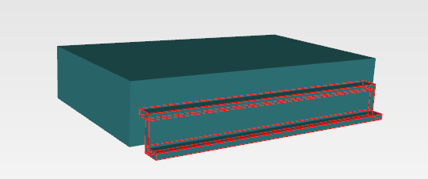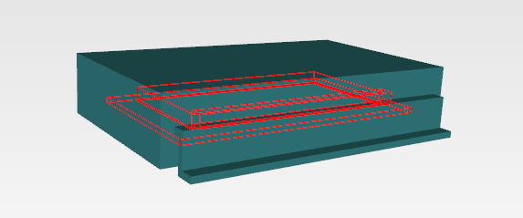

Die

Die Flag

Bond Wires

Encapsulant

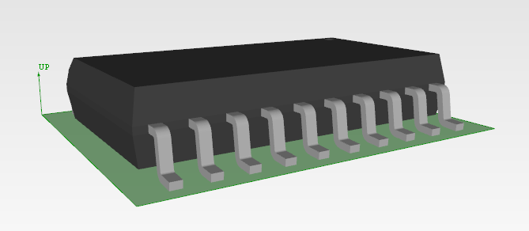

Terminal

Package Body

Seating Plane

Terminals

**Figure 3. Features of both thermal analysis representation and detailed design representation are shape_aspects of the package that are related to elements of the geometric model within their respective shape_representation.**



Terminal

Package Body



Die

Die Flag

Bond Wires

**Figure 4. Each of the features of the thermal analysis representation of the package is associated with elemenets of the geometric model. In this package models used in the case study, each feature is has its own shape_representation which is mapped into the thermal analysis shape_representation.**



**Figure 5. Mechanical components such as a heat sink may be represented as a physical_unit with multiple shape_representations.**

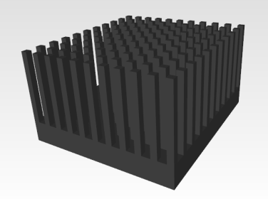

**Figure 6. Multiple physical properties (Assigned_shape_property) may be associated either directly with a shape_aspect or indirectly through a composite_group_shape_aspect.**



**Figure 7. Representation of material property (thermal conductivity) with a derived_unit.**



**Figure 8. A two-resistor network model and a potential topology for a Delphi compact thermal model. Reproduced from JEDEC Publications JESD15-3 Figure 7 and JESD15-4 Figure 8.**

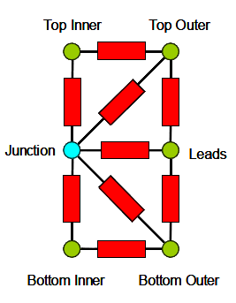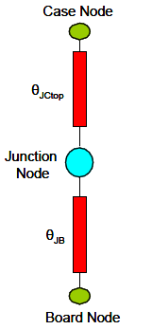

**Figure 9. Key entities and relationships used in the definition of a thermal network.**



**Figure 10. Key entities and relationships used in the representation of a thermal resistor.**



**Figure 11. Mechanisms for expressing the location of a thermal_network_node_definition.**



**Figure 12. The case study consisted of a representative PCA within an enclosure with a fan and heat sink (top). Below are the library components and PCA after import into FloTHERM.**

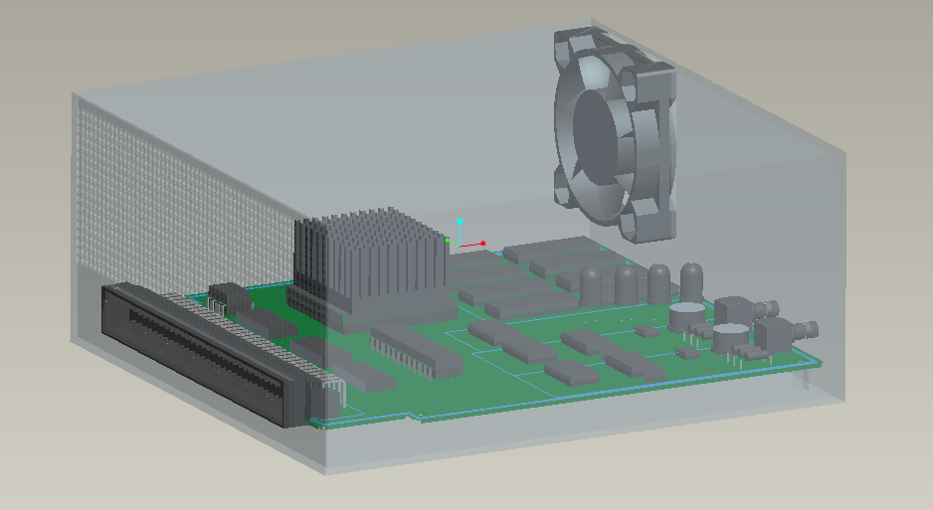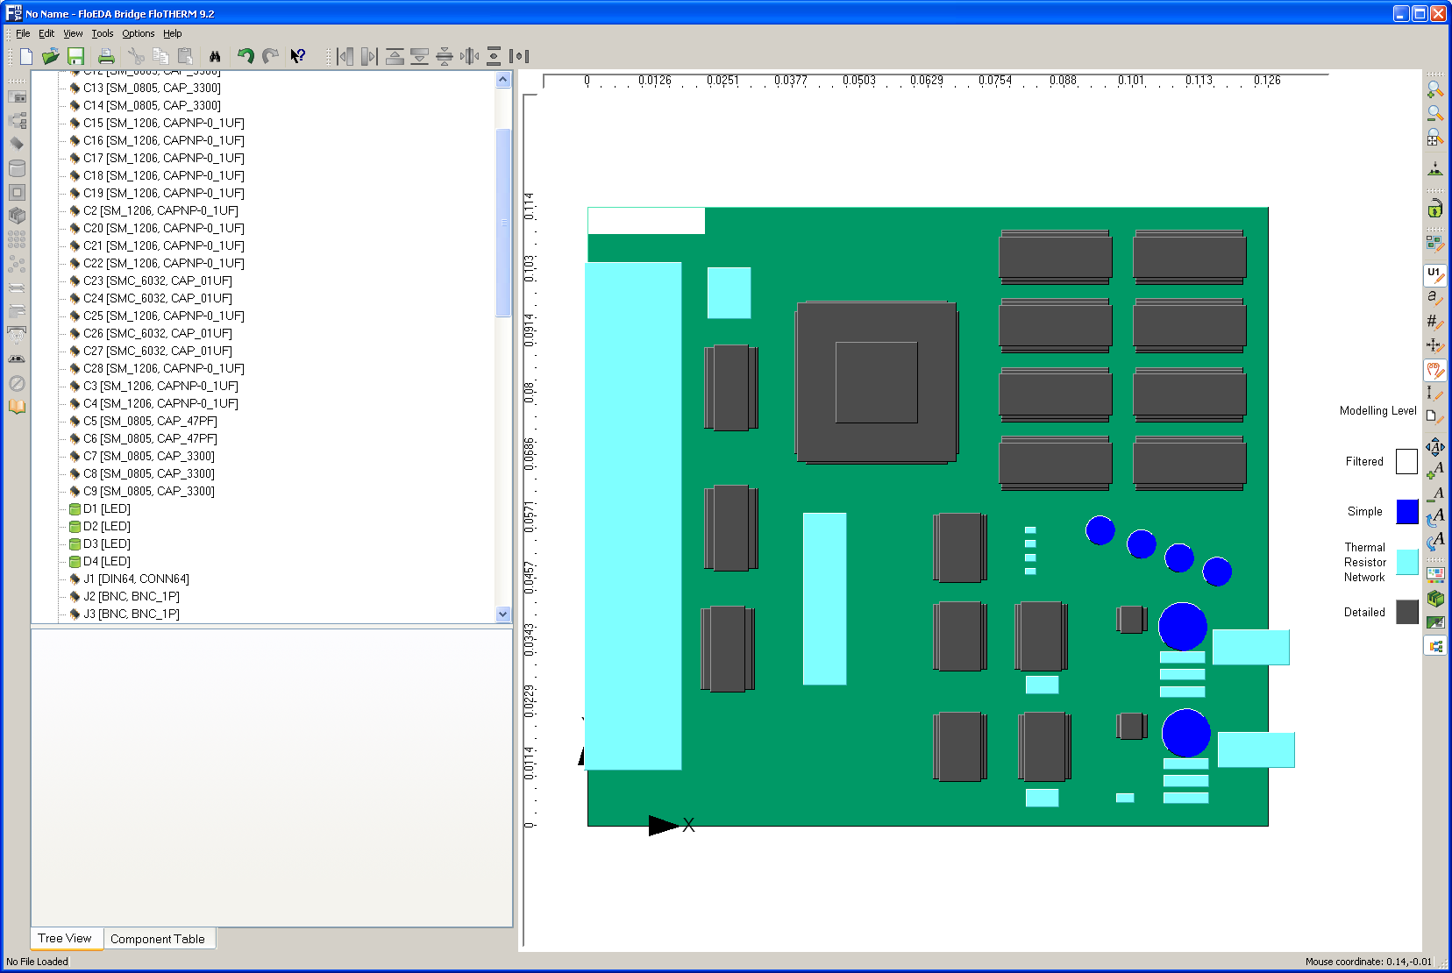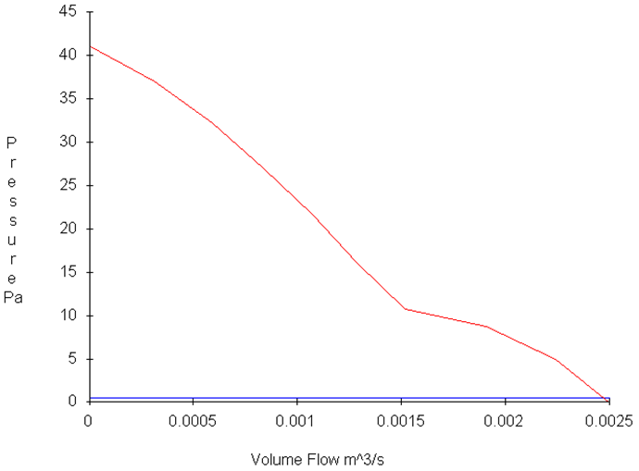

Fan – Sanyo Denki 109P0412H902 (40x40x10)

**Figure 13. The power dissipation levels prescribed for the components in the case study.**

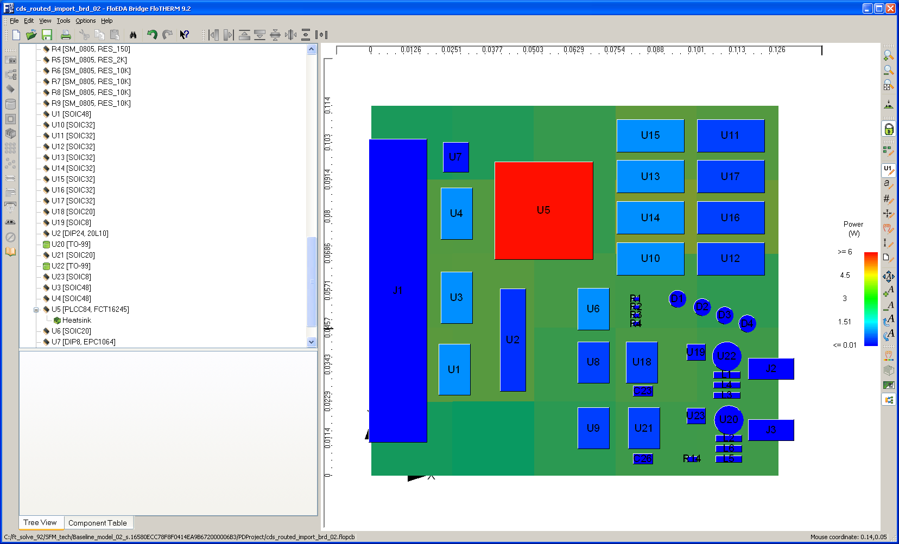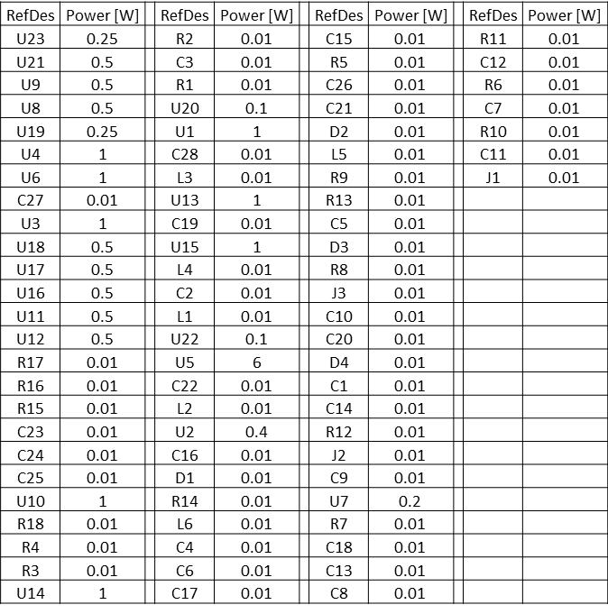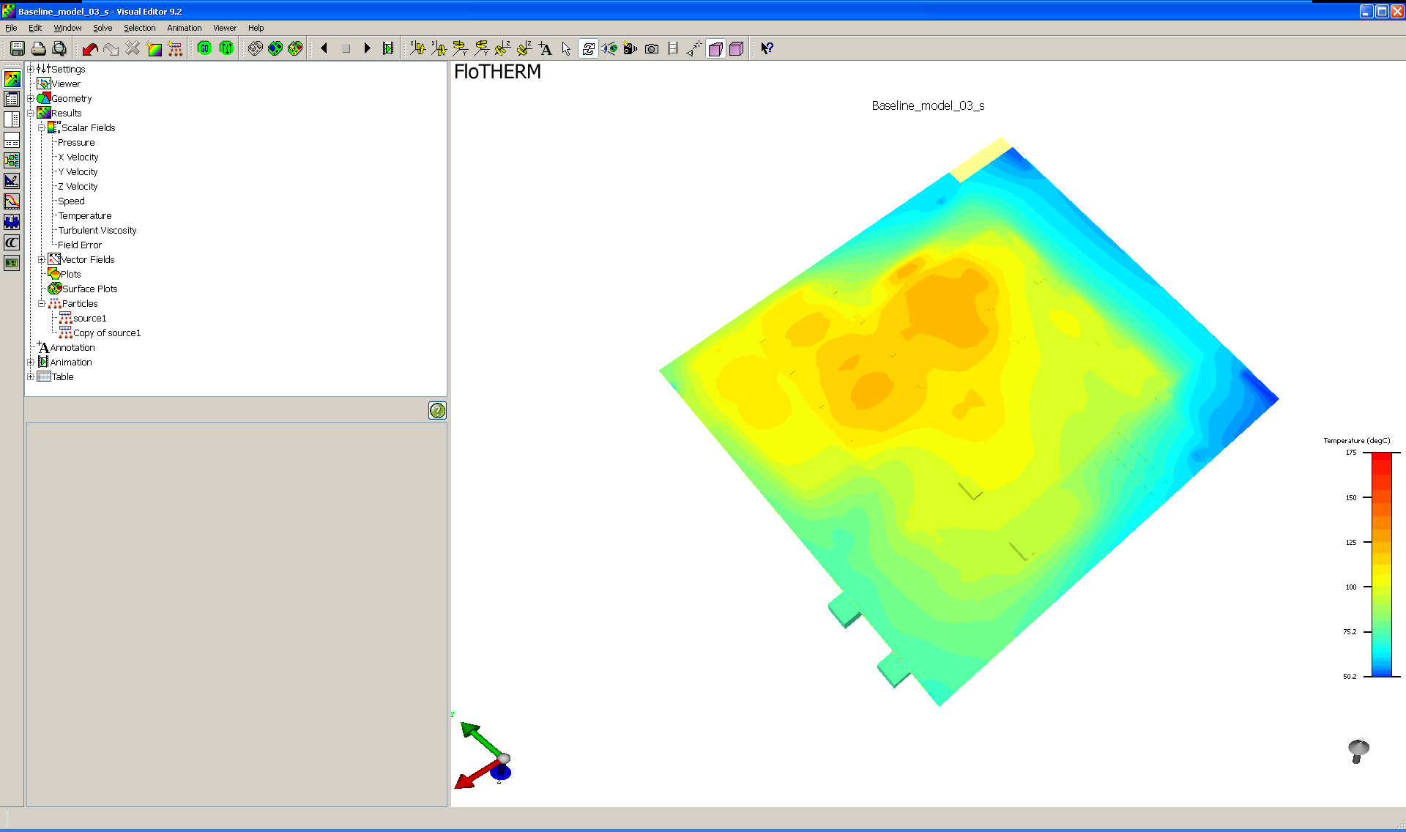

**Figure 14. Steady-state temperature distribution and airflow without heatsink.**

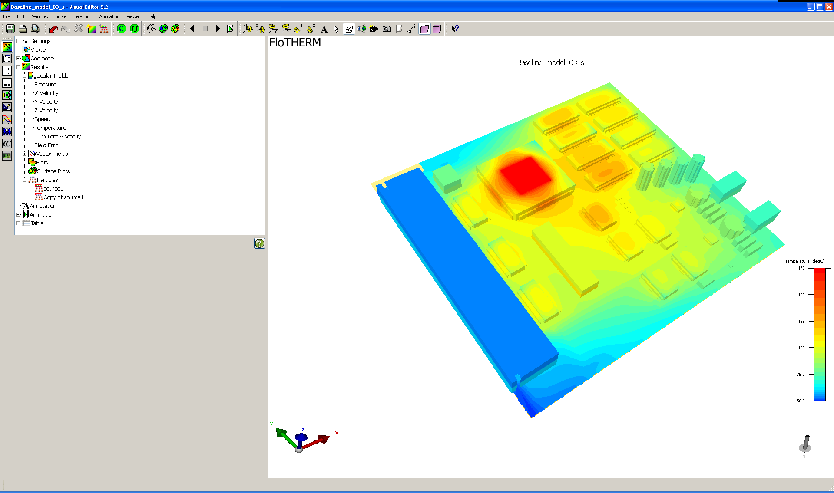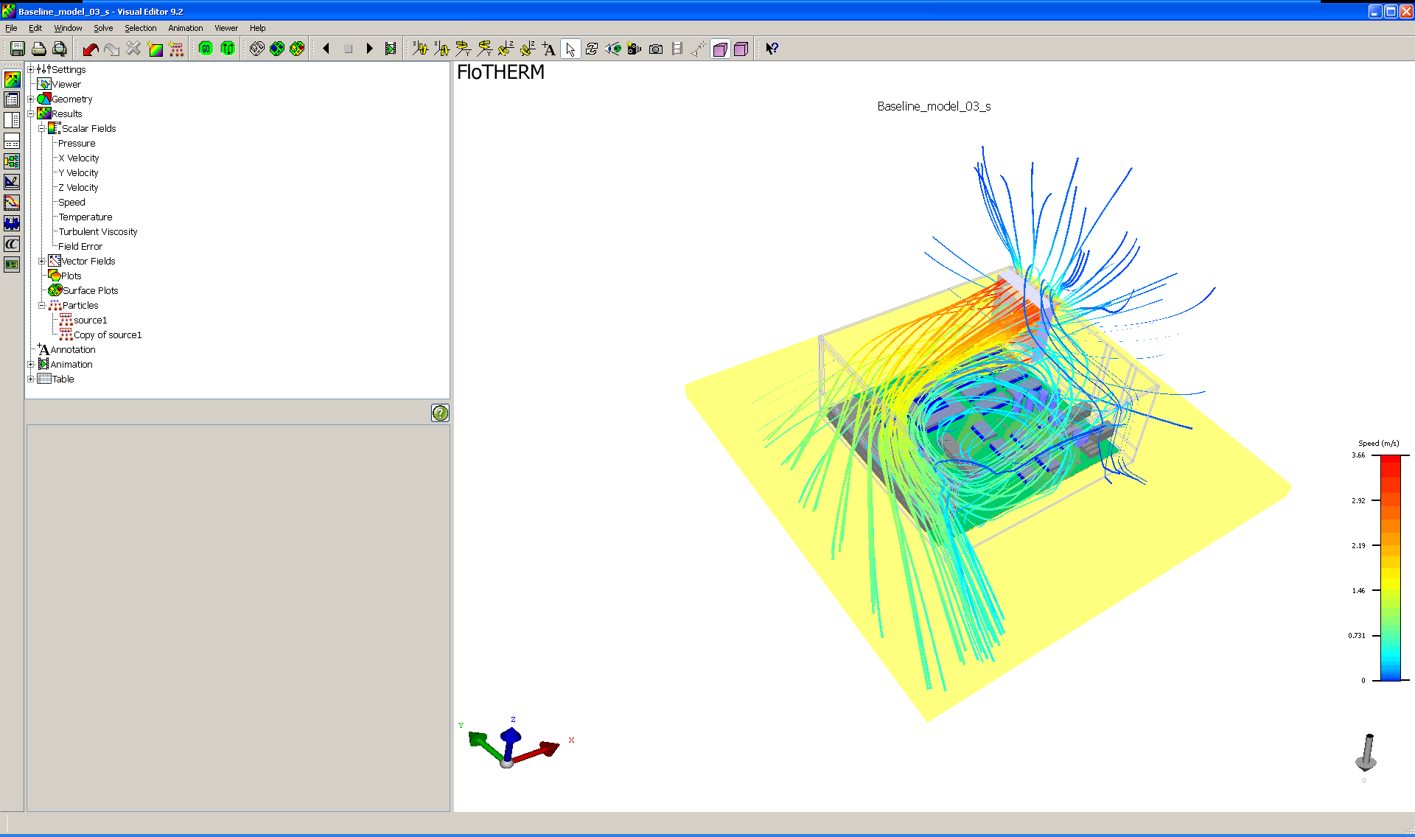

Note that the color scales in   
Figures 14 and 15 are not equal.

**Figure 15. Steady-state temperature distribution after addition of heatsink.**

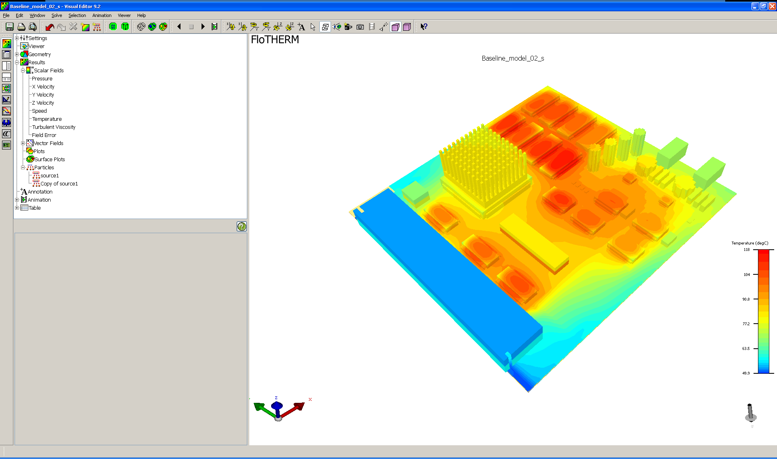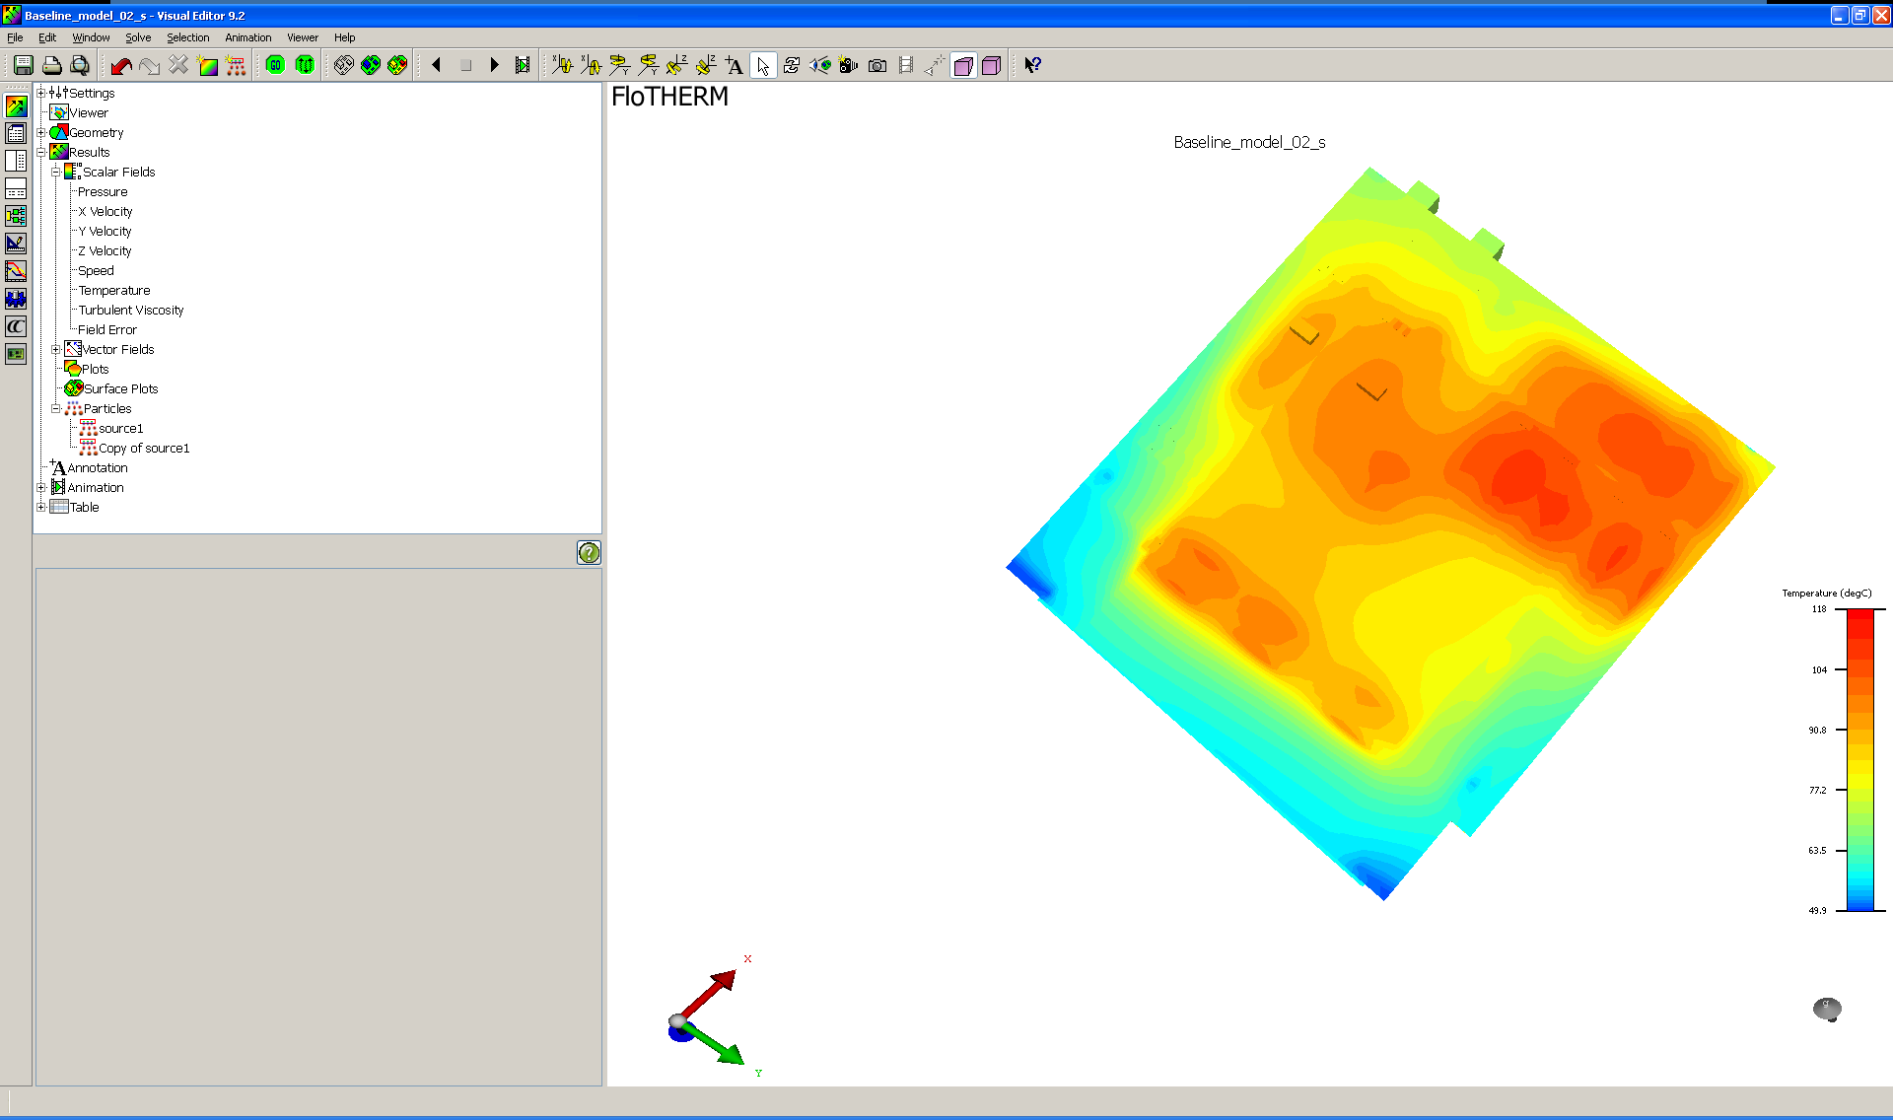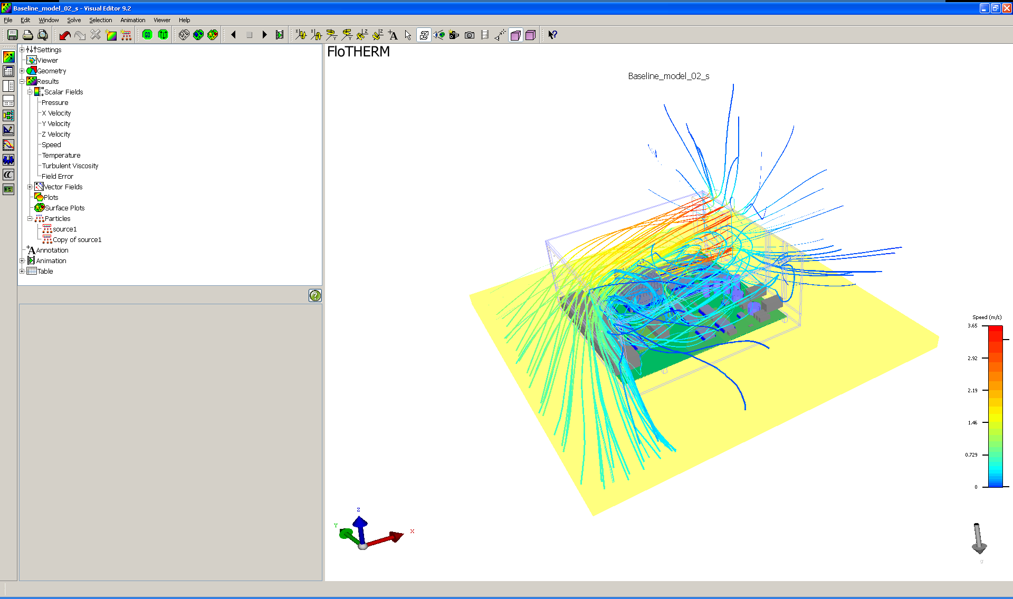

Note that the color scales in   
Figures 14 and 15 are not equal.

**Figure 16. Steady-state temperature before (top) and after (bottom) addition of heatsink.**

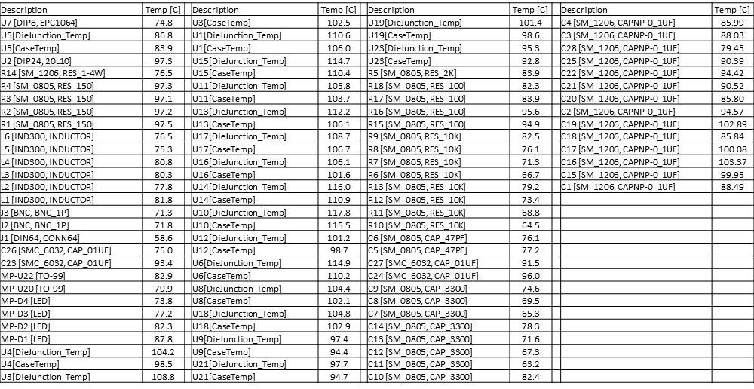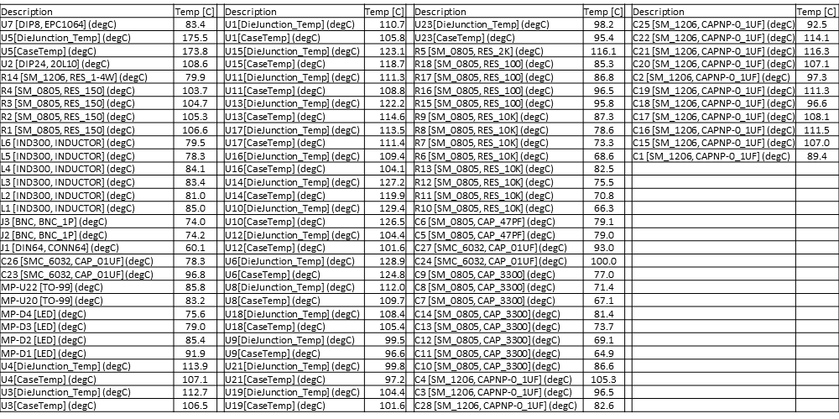

1. Sarang Shidore “Thermal Analysis of IC Packages”, Application Note, <http://www.coolingzone.com/library.php?read=518>
2. Sarang Shidore “Building a Good Detailed Model”, Application Note, <http://www.coolingzone.com/library.php?read=524>
3. Sarang Shidore “Detailed Modeling - The Die”, Application Note, <http://www.coolingzone.com/library.php?read=525>
4. Sarang Shidore “Detailed Modeling - The Lead Frame”, Application Note, <http://www.coolingzone.com/library.php?read=526>
5. Sarang Shidore “Package Substrates”, Application Note,   
   <http://www.coolingzone.com/library.php?read=527>
6. JESD15-3 “*Two-resistor compact thermal model guideline,”* [*www.jedec.org*](http://www.jedec.org)
7. JESD15-4, “*DELPHI Compact Thermal Model Guideline,”* [*www.jedec.org*](http://www.jedec.org)
8. Shidore, S., and Sahrapour, A., “DELPHI Compact Models Revolutionize Thermal Design,” <http://www.mentor.com/products/mechanical/techpubs/delphi-compact-models-revolutionize-thermal-design-47764>
9. Stori, J., Brady, K., and Thurman, T., “Representation of a Thermal Resistor Network Model of a Packaged Component in STEP AP210 Edition 2” NIST Internal Report (NISTIR) 7648, <http://www.nist.gov/manuscript-publication-search.cfm?pub_id=903903>
10. As the Flowtherm XML input format does not currently support the more generalized Delphi network models, only two-resistor network representations were validated in the case study. However, the AP210 modeling methodology and functional network representation is completely analogous to that of the two-resistor case.